Format of Question paper for Comprehensive Examination

Birla Institute of Technology & Science, Pilani
Work Integrated Learning Programmes Division
First Semester 2024-2025

Comprehensive Examination
(EC-3 Regular)

Course No. : AIML CL ZG513
Course Title : Advanced Deep Learning
Nature of Exam : Open Book
Weightage : 40%
No. of Pages = 2
No. of Questions = 4

Duration : 2 Hours 30 Minutes
Date of Exam :
Note to Students:
- Please follow all the Instructions to Candidates given on the cover page of the answer book.
- All parts of a question should be answered consecutively. Each answer should start from a fresh page.
- Assumptions made if any, should be stated clearly at the beginning of your answer.

Q.1. [5+5+2=10 Marks]

- Consider a standard DCGAN architecture which has a discriminator that takes as input 64x64 gray images and classifies these into real (1) and fake (0) images. It has 2 convolution layers with 25 and 50 channels. The discriminator conforms to the best practices of DCGAN construction. If global average pooling along with a softmax based FC layer is used,
- calculate the total number of training parameters. Show all steps clearly to get partial marks.
- If training data consists of 15 classes, and DCGAN is trained to classify an input to 16 classes (15 training labels and one different from all 15 training labels) what will be total number of trainable parameters if an additional fully connected hidden layer with 50 nodes is used.

- How is clipping related disadvantages of WGAN eliminated? Which architecture incorporates this strategy?

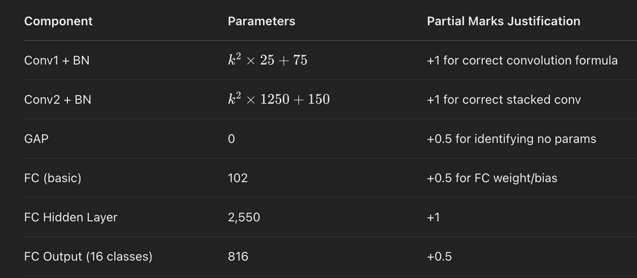

Part B: Clipping in WGAN and Its Alternative Strategy
Issue with Weight Clipping in WGAN:
- Wasserstein GAN (WGAN) originally used weight clipping to enforce the Lipschitz constraint.
- This causes:
  - Capacity reduction: Clipping forces discriminator weights into a small range, limiting learning ability.
  - Vanishing gradients: If weights shrink too much, gradients become too small, slowing training.
  - Unstable training: If weights are clipped too loosely, the discriminator may not satisfy the Lipschitz condition properly.
Solution: Gradient Penalty in WGAN-GP
- Instead of weight clipping, WGAN-GP (WGAN with Gradient Penalty) enforces the Lipschitz constraint by adding a gradient penalty term to the loss function:
- Advantages of Gradient Penalty:
  - Avoids weight clipping issues.
  - Stabilizes training.
  - Allows a more expressive discriminator.
  - Leads to better gradient flow.
Architecture that Uses This:
- WGAN-GP (Improved Wasserstein GAN with Gradient Penalty).

Final Answers:
- Total parameters in DCGAN discriminator (original setup): 1275k^2+277
- Total parameters with extra FC hidden layer (for 16 classes):1275k^2+3643
- Clipping issue in WGAN: Causes vanishing gradients and limited capacity.

- Solution:
  - WGAN-GP uses gradient penalty instead of weight clipping.
  - spectral normalization is another effective solution to the weight clipping problem in WGAN — and more broadly, it helps in stabilizing GAN training.

Q.2. [3+4+3+4=14 Marks]

- Which of the following transformation function can be used for flow-based models? Why? Show all steps.
- f(x) = exp(-x²)
- f(x) = log(1+exp(x))
- Calculate the Lipschitz constant for the following functions? Which of these can be used in WGAN?
- f(x) ≡ e^{-|x|}
- f(x) ≡ log(1+exp(x))
- Let P = 1/(2π) *exp (-x²/2 - y²/2) and Q = 1/(12π) *exp (-x²/8 -y²/18) be two bivariate normal distributions. Calculate the Frechet Inception Distance between P and Q.

- Let μ₁ = 1/λ₁ * exp(-λ₁x) and and μ₂ = 1/λ₂ * exp(-λ₂x) be two exponential distributions. Calculate
- the JS Divergence JSD (μ₁|| μ₂)
- JSD (μ₂|| μ₁)
- KLD (μ₁|| μ₂)
- Will KLD (μ1|| μ2) and KLD (μ₂|| μ₁) be the same or different?

_{Q.3.} [2+3+1+1+1+1=9 Marks]

- Why is it necessary to consider both inception score as well as Frechet inception distance for evaluating data generation using GAN?

Inception Score (IS): Measures the quality and diversity of generated images. Uses a pre-trained Inception model to classify generated images. A high inception score indicates that the images are both high quality (clear and recognizable) and diverse (spread across many classes). It does not consider the real data distribution, only the diversity and quality of generated images.
Frechet Inception Distance (FID): Measures the similarity between the distribution of generated images and real images. Computes the distance between the feature vectors of real and generated images using the Inception model. A lower FID indicates that the generated images are more similar to the real images. Considers both the quality and diversity of images in relation to real data.

Why both are necessary:
• Complementary Metrics: IS focuses on the diversity and quality of generated images, while FID measures how close the generated images are to the real data distribution. Using both provides a more comprehensive evaluation of GAN performance.
• Balanced Evaluation: IS might be high even if the generated images are not similar to real images, while FID ensures that the generated images are not only diverse but also realistic.

- Consider a simplified VAE model, where the reconstruction loss is the squared error between a data point x and its reconstruction x̂, and the KL divergence measures the difference between the distribution of the latent variable z and the standard normal distribution. Given a data point x=5, its reconstruction x̂=4, the mean μ=0, and variance σ²=1 of the latent variable, calculate the loss for this data point.

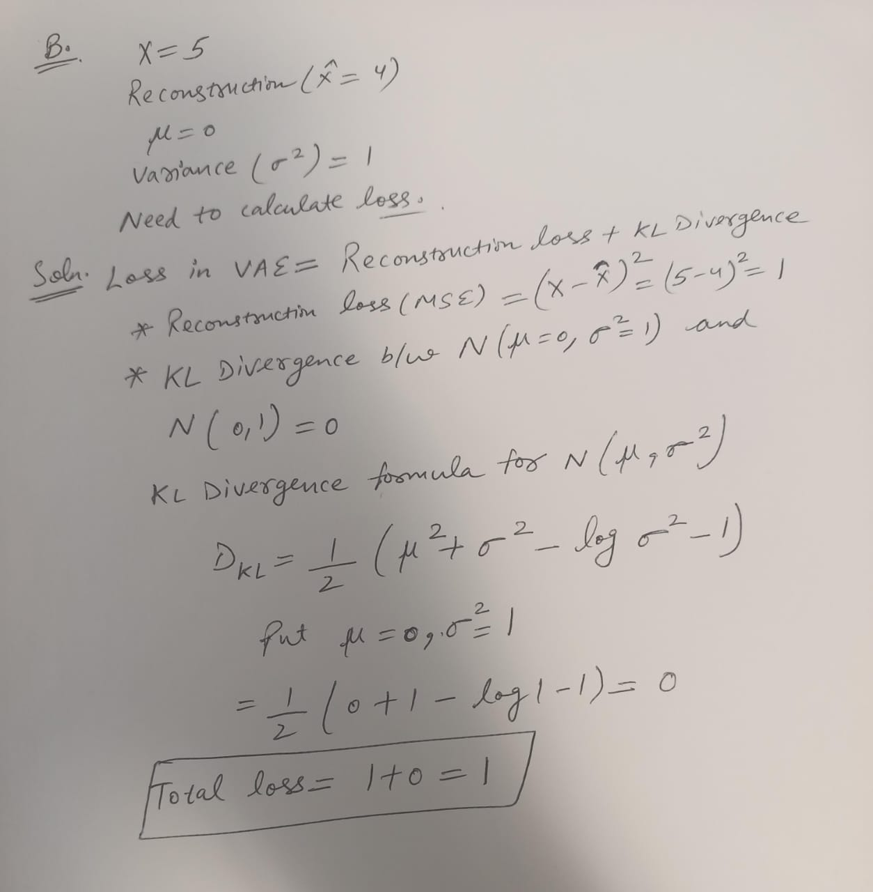

- Explain what the role of the reparameterization trick in VAE is and why this trick is crucial for training the model.

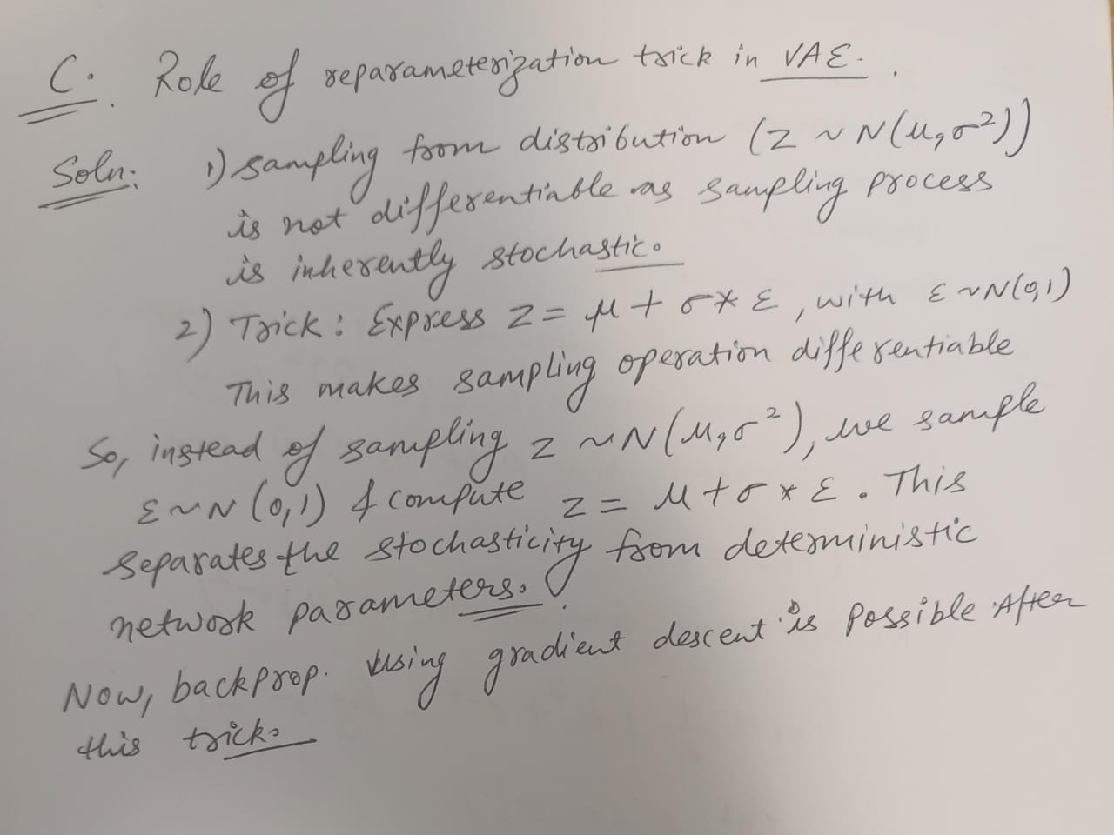
- When training a VAE model, you may encounter issues where the model fails to learn useful information, resulting in blurred or unclear generated images. List two ways to address this issue.

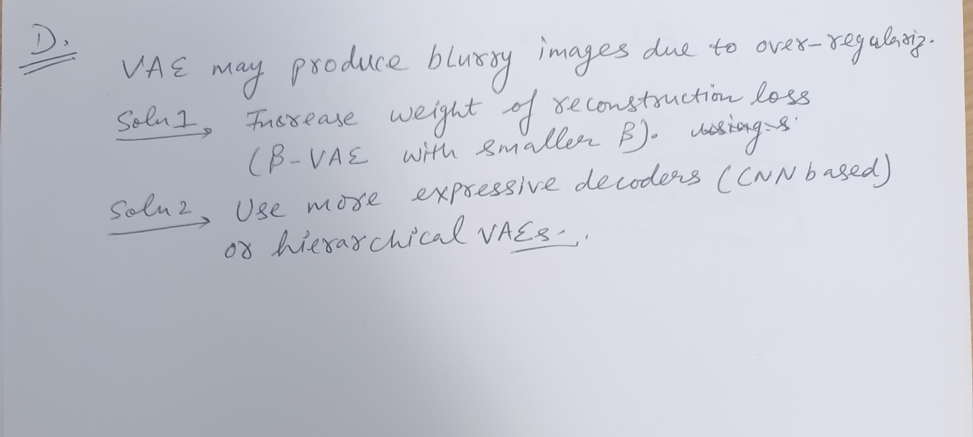

- Consider the application of VAEs in image denoising. Describe how VAEs can be used to remove noise from images and explain the underlying principle.

• Latent Space Representation: VAEs learn a compressed representation of the input data in the latent space, capturing the essential features while ignoring noise.
• Denoising Process: During training, the VAE learns to reconstruct clean images from noisy inputs. At inference, the VAE can take a noisy image, encode it to the latent space, and decode it back to a denoised version.

- How can VAE be tuned for disentangled features?

1. Beta-VAE: Adjust the (beta) parameter to encourage disentanglement by penalizing the KL divergence more heavily (Higher beta ~>1), promoting independence between latent variables.
2. FactorVAE: Introduce an additional regularization term to explicitly encourage disentanglement by penalizing the total correlation in the latent space.

Q.4. [3+4=7 Marks]

Consider a fully connected autoencoder (each hidden node is connected to all inputs and all outputs) with two-dimensional binary input and one hidden layer with sigmoid activation function. At iteration t, the weights are shown in the following autoencoder architecture along with the input vector (x1=1, x2=1). All bias values are zero. Assume learning rate = 0.3 and momentum constant = 0.5. Also assume at t-1, w1= -0.5, w2=0.5, w3=0.5 and w4= -0.5.

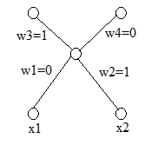
- What will be the value of loss function at iteration t? Choose appropriate activation function and loss function.
Activation function: sigmoid
Loss function: binary cross entropy
Hidden output = 1/(1+exp(-1))=0.731

Output=(1/(1+exp(-0.731)), 0.5)=(0.675,0.5)

Loss function value=-1*ln(0.675)-1*ln(0.5)=1.086
- What will be the weights w1 and w3 in iteration t+1 assuming backpropagation with momentum update is used?
Without momentum update,
w3(t+1) = 1-0.3*(0.675-1)*0.731=1.071
w1(t+1) = 0-0.3*(0.675-1) * 0.731*(1-0.731)=0.019
With momentum update,
w3(t+1)=0.25+1.071=1.321
w1(t+1)=0.25+0.019=0.269

